From Raw Imaging to Neural Motifs: My Custom Data Preprocessing Pipeline

Prepared by Zhiyao (Mike) Zhang
Research Assistant, Cleveland Clinic Lerner Research Institute
Note on Scope
This document outlines the methodological architecture and my contributions. In adherence with lab data governance policies, proprietary code, raw datasets, and specific implementation details are not disclosed.
FlowChart
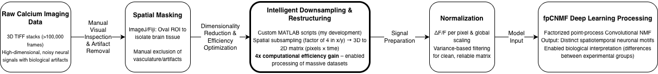
Key Technical Contributions
- Developed and standardized masking protocol in ImageJ to eliminate non-neural artifacts while preserving critical brain regions.
- Engineered custom MATLAB scripts for intelligent downsampling and 3D-to-2D restructuring, achieving fourfold improvement in computational efficiency and enabling the processing of 100,000+ frames within feasible timeframes.
- Implemented a variance-based normalization and filtering protocol to ensure data suitability for advanced deep learning decomposition.
- Successfully deployed the fpCNMF deep learning model atop this pipeline, enabling the discovery of biologically significant neural patterns.
Project Outcome & Demonstrated Skills
This end-to-end pipeline, which I architected, was critical to the project's success. It transformed raw, high-dimensional imaging data into reliable inputs, directly enabling the subsequent discovery of distinct neuronal motifs that differentiated between experimental groups.
Core Skills: Data Pipeline Architecture • MATLAB Scripting • ImageJ/Fiji Processing • Dimensionality Reduction & Optimization • Signal Normalization (ΔF/F) • Deep Learning Integration (fpCNMF) • Efficiency Engineering • Research Documentation & IP Compliance

